**BMI CALCULATOR**

**A MINI PROJECT REPORT**

**Submitted by**

**Group no: G-12**

Akashdeep Singh;2410990904

Anshul Makhija;2410990930 Archin Munjal ;2410990939

*in partial fulfillment for the award of the degree*

*of*

**BACHELEOR OF ENGINEERING**

*in*

CSE



**CHITKARA UNIVERSITY**

**CHANDIGARH-PATIALA NATIONAL HIGHWAY**

**RAJPURA (PATIALA) PUNJAB-140401 (INDIA)** October 2024

# Abstract

**The BMI (Body Mass Index) Calculator project is a software application designed to calculate and assess an individual's person has a healthy body weight relative to their height. This project aims to provide an efficient and user-friendly tool that enables users to input their weight and height, then instantly receive their BMI score and corresponding health classification—such as underweight, normal, overweight, or obese—based on World Health Organization (WHO) guidelines. The project utilizes a simple mathematical formula to compute the BMI and presents the results in an intuitive and accessible format. The BMI Calculator can serve as a basic health monitoring tool, aiding individuals in tracking their fitness and encouraging better health management. Future iterations of the project could incorporate additional features like unit conversion, personalized health advice, and integration with other health metrics to enhance user engagement and utility.**

# Table of content

|  |  |  |
| --- | --- | --- |
| **Sr.**  **no**  **.** | **section** | **Pag**  **e no.** |
| **1** | **introductio n** |  |
| **2** | **Problem Statement** |  |
| **3** | **Technical**  **Details** |  |
| **4** | **Key Features** |  |
| **5** | **Project Advantages** |  |
| **6** | **Results** |  |
| **7** | **Coding** |  |
| **8** | **Conclusion with future scope** |  |

# Introduction

**Our team consisting of Akashdeep Singh as the team leader and Anshul Makhija ,Archin Munjal as the team member has developed a BMI Calculator as part of our project. This tool is designed to calculate an individual's BMI based on their weight and height, providing a quick and easy way to assess whether a person is underweight, normal weight, overweight, or obese according to standard health guidelines. The primary goal of this project is to create a user-friendly application that promotes health awareness and enables users to monitor their body weight relative to their height. Through this, we aim to contribute to healthier lifestyle choices and support preventive healthcare efforts.**

# Problem Statement

**In today's world, obesity and undernutrition are growing health concerns, affecting millions of people globally. Many individuals lack the awareness or access to tools that help them understand their current health status in relation to their body weight. Without proper monitoring, people may unknowingly be at risk of developing serious health issues such as diabetes, heart disease, or malnutrition. The problem is further compounded by the complexity of determining a healthy weight relative to one's height, which can be confusing for the average person. By creating a BMI calculator, we aim to provide a simple and accessible solution that allows individuals to quickly assess their health status based on their BMI. This tool will empower users to take proactive steps towards maintaining a healthier lifestyle by offering immediate feedback on their weight-to-height ratio.**

# Technical details

**HTML CSS JAVASCRIPT**



# Key feature

***The key feature of a BMI Calculator:-***

* **Its ability to quickly and accurately calculate a user's BMI based on their weight and height.**
* **It then provides an output that categorizes their BMI into ranges like underweight, normal weight, overweight, or obese based on standard health guidelines.**

# Project

**Advantages:**

1. **Simple and Easy to Calculate: BMI is calculated using a straight forward formula based on a person's weight and height, making it simple and easy to calculate without the need for specialized equipment or measurements.**

1. **Widely Accepted Standard: BMI is a widely accepted standard for assessing weight status and obesity risk. It is recognized by healthcare professionals, researchers, and public health.**

**RESULT:**

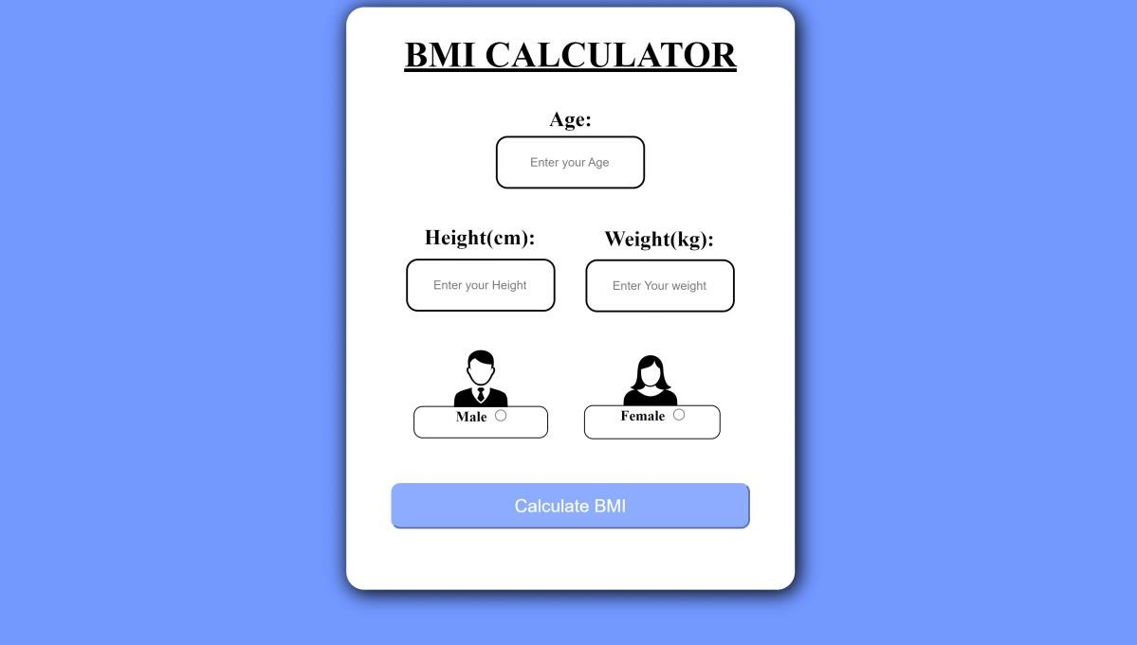

**CODE:**

**html**

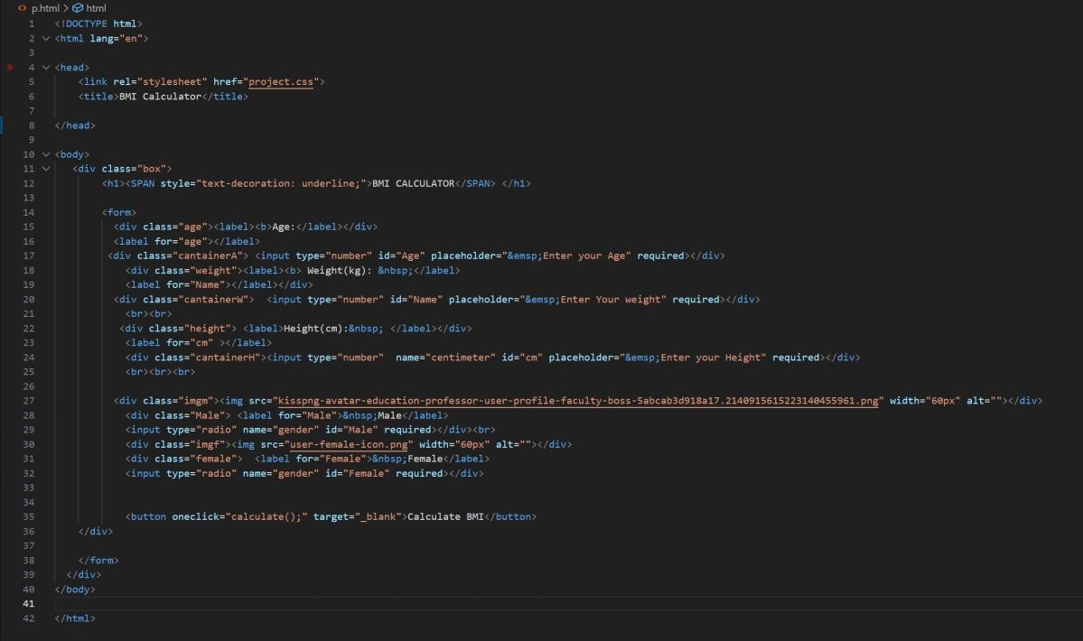

**CSS**

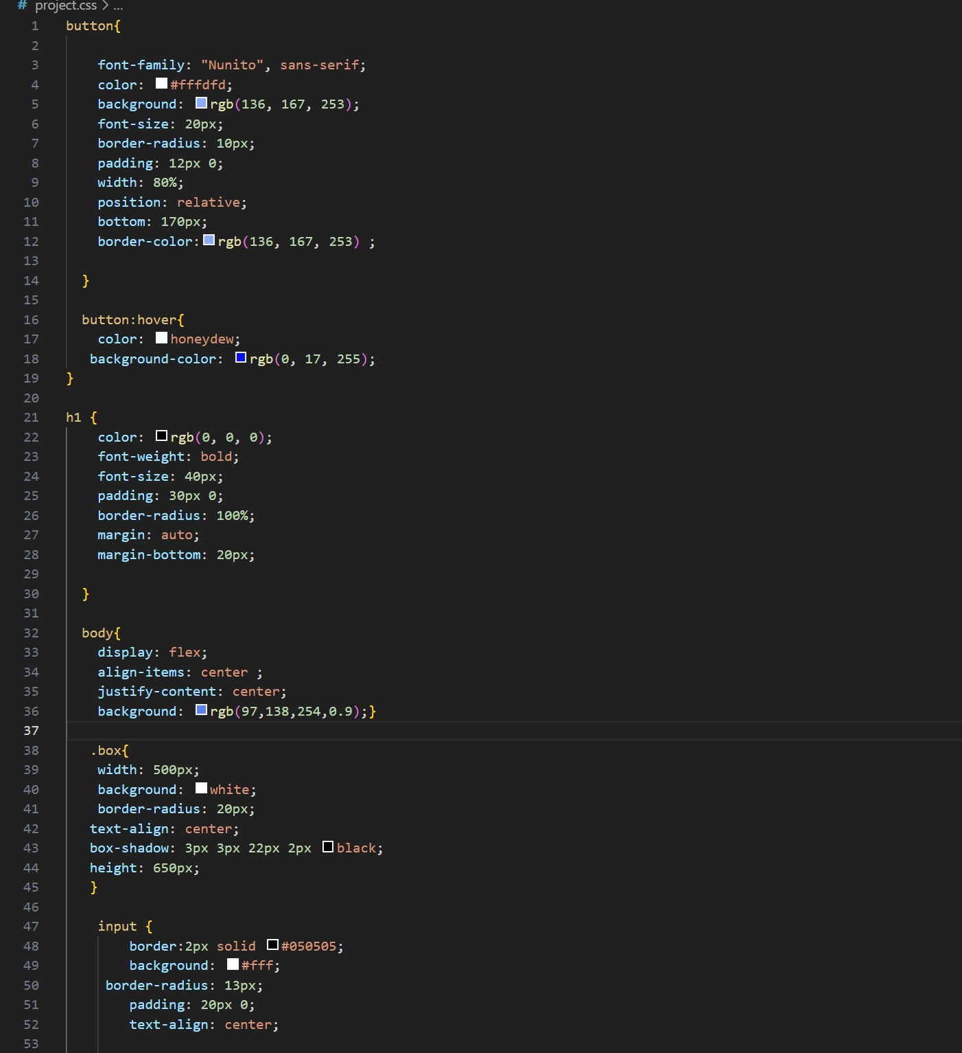

**JS code:**

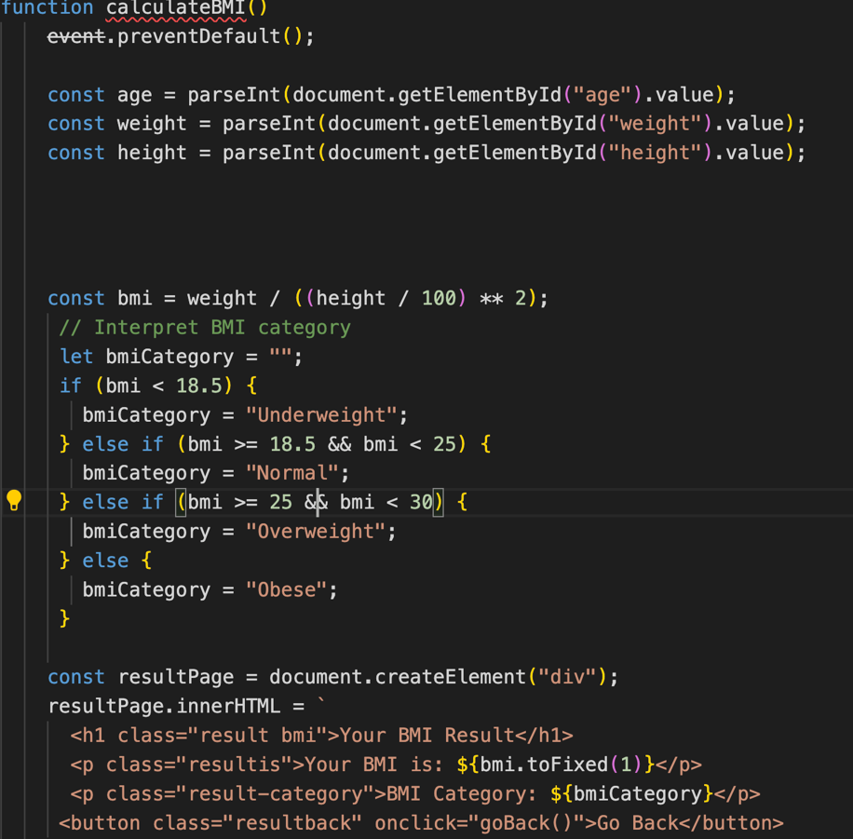

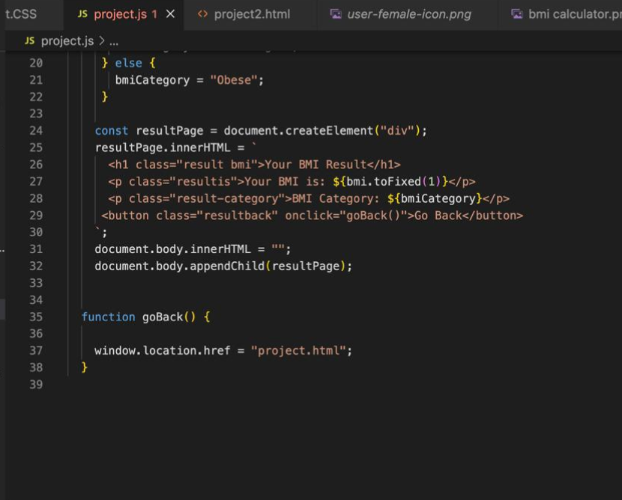

# Conclusion and

**Future Scope**

***Conclusion:***

**In this project, the BMI (Body Mass Index) calculator was successfully developed to help individuals assess their weight status relative to their height. The calculator provides a simple, user-friendly interface that allows users to input their height and weight to calculate their BMI, which in turn categorizes them into different health risk groups (underweight, normal weight, overweight, or obese). This tool can serve as an initial step for individuals to better understand their overall health and potentially make lifestyle adjustments.**

**The implementation of the BMI calculator demonstrates the power of technology in promoting health awareness. By providing instant feedback, users can gain insights into their health and well-being with minimal effort. However, it’s important to note that BMI is a basic measure and doesn’t account for all variables such as muscle mass, bone density, and fat distribution.**

***Future Scope:***

**1. *Integration with Health Databases:* The BMI calculator can be integrated with health databases to track a user’s progress over time, offering more personalized advice based on their health history.**

## 2. *Diet and Exercise Recommendations:*

**Based on the user’s BMI results, the calculator could offer personalized diet and exercise suggestions. This could help users manage their weight more effectively.**

**3.*Machine Learning Integration:* Implementing machine learning could help in predicting future health risks based on trends in a user’s BMI and other health data.**

**By expanding on these features, the BMI calculator could evolve into a comprehensive health monitoring tool that offers deeper insights and more personalized health recommendations.**